**Steps for Creating A bucket and Uploading an object as public.**

Step 1 : Firstly log in your account(Root Or IAM user) in AWS Management Console.

Step 2 : Go the S3 (Simple Storage Service) from services.

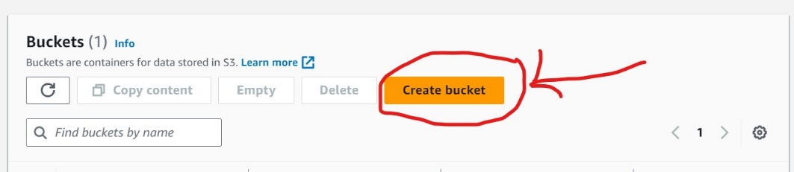Steps 3 : then go to create bucket.

Step 4 : name the bucket as in following rule---

The following rules apply for naming buckets in Amazon S3:

* Bucket names must be between 3 (min) and 63 (max) characters long.
* Bucket names can consist only of lowercase letters, numbers, dots (.), and hyphens (-).
* Bucket names must begin and end with a letter or number.
* Bucket names must not contain two adjacent periods.
* Bucket names must not be formatted as an IP address (for example, 192.168.5.4).
* Bucket names must not start with the prefix xn--.
* Bucket names must not end with the suffix -s3alias. This suffix is reserved for access point alias names. For more information, see [Using a bucket-style alias for your S3 bucket access point](https://docs.aws.amazon.com/AmazonS3/latest/userguide/access-points-alias.html).
* Bucket names must not end with the suffix --ol-s3. This suffix is reserved for Object Lambda Access Point alias names. For more information, see [How to use a bucket-style alias for your S3 bucket Object Lambda Access Point](https://docs.aws.amazon.com/AmazonS3/latest/userguide/olap-use.html#ol-access-points-alias).
* Bucket names must be unique across all AWS accounts in all the AWS Regions within a partition. A partition is a grouping of Regions. AWS currently has three partitions: aws (Standard Regions), aws-cn (China Regions), and aws-us-gov (AWS GovCloud (US)).
* A bucket name cannot be used by another AWS account in the same partition until the bucket is deleted.
* Buckets used with Amazon S3 Transfer Acceleration can't have dots (.) in their names. For more information about Transfer Acceleration, see [Configuring fast, secure file transfers using Amazon S3 Transfer Acceleration](https://docs.aws.amazon.com/AmazonS3/latest/userguide/transfer-acceleration.html).

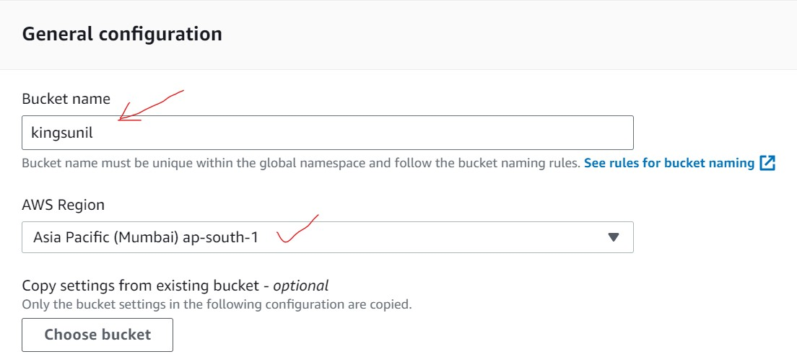Step 5 : Disable **Block Public Access settings for this bucket as it making publicly to accessing .**

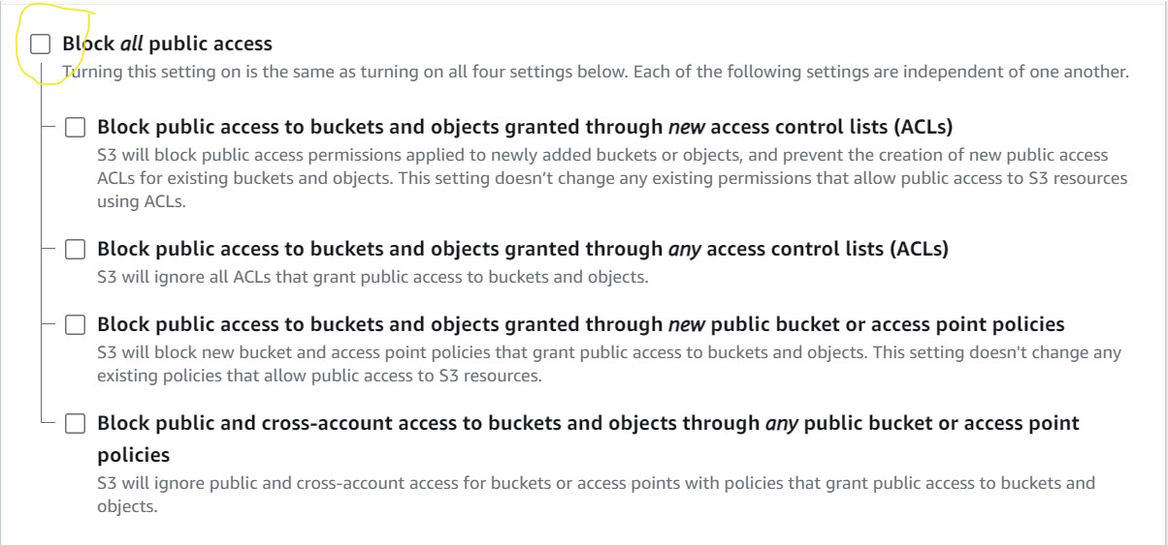

Step 6 : tick this action as we want to public my bucket.

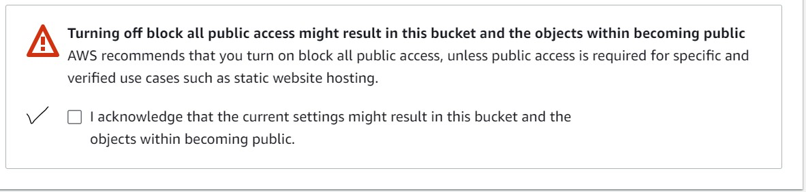

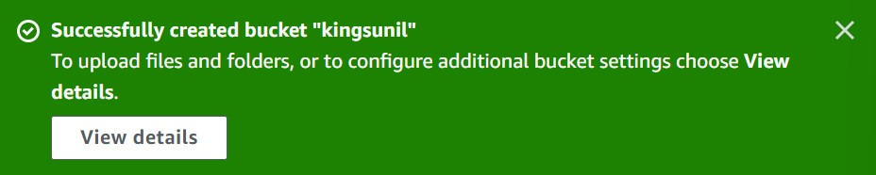step 7 : our bucket is created .

step 8 : now upload an object.

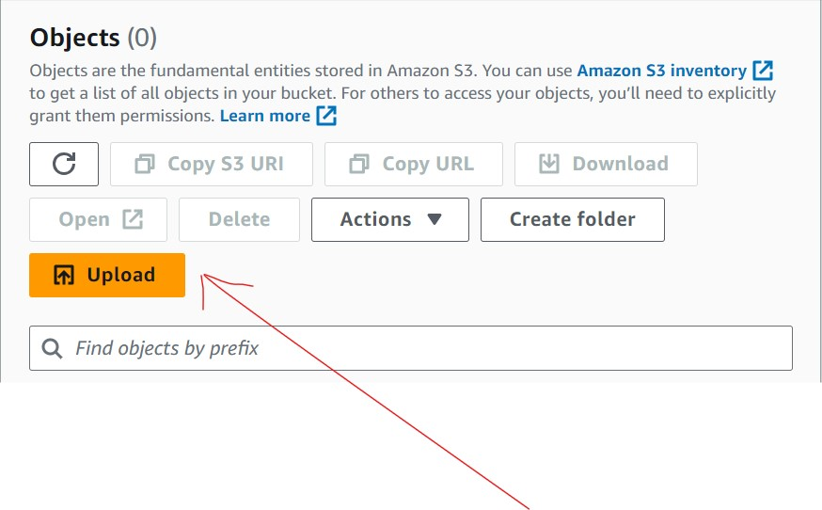

Step 9 : Now go to the permissions of bucket to edit the policy of bucket.

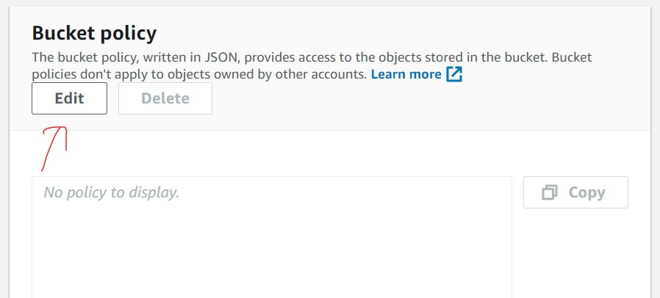

Step 10 : then go to generate policy .

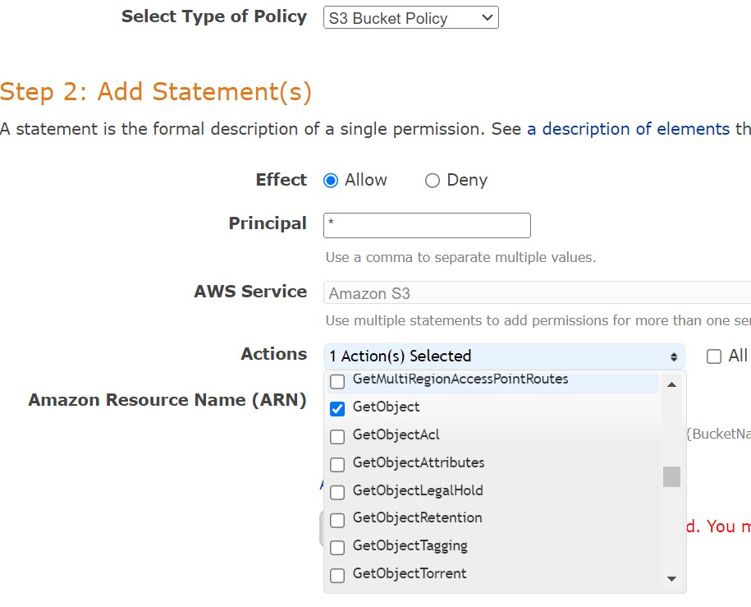

Step 11: now copy the ARN from previous window.

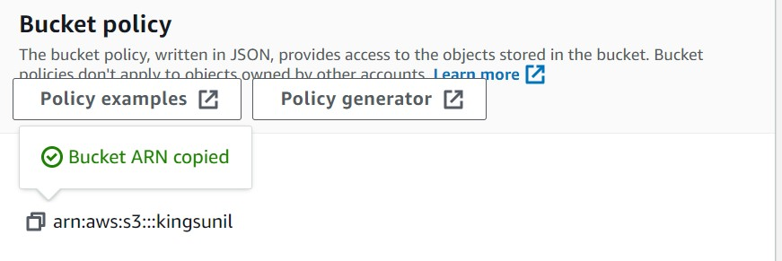

After that generate the policy and copy from it then paste it to the are of policy and save the policy.

Don’t forget add “/*” in policy where the bucket name is written.

{

"Id": "Policy1689346310063",

"Version": "2012-10-17",

"Statement": [

{

"Sid": "Stmt1689345937541",

"Action": [

"s3:GetObject"

],

"Effect": "Allow",

"Resource": "arn:aws:s3:::kingsunil/*",

"Principal": "*"

}

]

}

Now your bucket is ready to accessible public now share public URL to share with your friends .

